ILLINOIS TRACTION SOCIETY
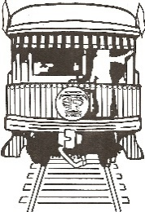
39TH Annual Meet – April 24-25, 2026 – Decatur

MOTELS

DECATUR/FORSYTH

COMFORT INN 5170 N. WINGATE DR. (217) 875 5500

COUNTRY INN SUITES: 5150 HICKORY POINT FRONTAGE ROAD
(217)872-2402
BAYMONT INN & SUITES 5100 HICKORY POINT FRONTAGE ROAD
(217) 875 5800

FAIRFIELD INN 1417 HICKORY POINT DR (217) 875 3337

HAMPTON INN 1429 HICKORY POINT DR. (217) 877-5577

HAWTHORNE SUITES 2370 SOUTH MT. ZION RD (866) 597 9330

HOLIDAY INN & SUITES 5150 N. WINGATE DR. (217) 542 5400

HOMEWOOD SUITES 333 WEST MARION AVE. (217) 877-0887

QUALITY INN 134 EAST BARNETT (217) 872 6600

RAMADA LIMITED 355 EAST HICKORY POINT RD
(217) 876-8011
RESIDENCE INN 230 LUCIE AVE. (217) 872 6600

SLEEP INN 3920 HOSPITALITY LN (217) 8722 7700

